Exercise 1
- CREATE DATABASE addressbook;
- DESCRIBE employee_data;
- SHOW DATABASES;
- INSERT INTO employee_data
(f_name, l_name, title, age, yos, salary, perks, email)
VALUES
('Rudolf', 'Reindeer', 'Business Analyst', 43, 2, 95000, 17000, 'rudolf@bugnet.com');
- SELECT * FROM employee_data; & SELECT f_name, l_name, title, age, yos, salary, perks, email FROM employee_data
- 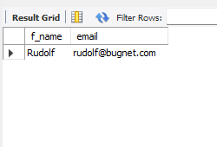
- SELECT salary, perks, yos FROM employee_data;
- SELECT COUNT(*) FROM employee_data;
- 